SECTION A (40 marks)

Answer ALL the questions in this question.

 (a) State two types of functions. (2 marks)

(b) Convert each of the following expressions from Octal to binary:

238

(ii) 468

(2 marks)

1. (a) Given the sets:



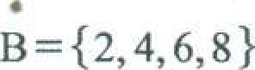

Determine:

(2 marks)



C

(b) Solve the equatio

(dc-3)2 +10c=760

(2 marks)

1. Solve the following simultaneous equation using matrices:

+ 6y 36

10c-0=22 (4 marks)

1. (a) Failure of students in an exam (x) is represented by a binomial distribution 

40, 0.3) . Determine the probability that exactly 15 students will fail.

(2 marks)

|  |  |
| --- | --- |
| (b) Outline two advantages of secondary data.  5. Solve for n in each of the following equations:   1. nn=LIO 2. ne=30xnP2 | (2 marks) |

(4 marks)

1. (a) The ages of 6 students in a class are:

17, 15, 18, 21, 14, 19

 Determine the median age. (2 marks)



* 1. Given the following matrix:

Determine B-l . (2 marks)

1. (a) The probability that Tom and Mary will pass in an interview is 0.4 and 0.5 respectively.

Determine the probability that both will fail in the interview. (2 marks)

* 1. Solve the following inequality:

# .5:c+5

S2c—1 (2 marks) -10

1. In a class of 100 students, 45 study history, 53 study English and 15 study both subjects.

Using a Venn diagram determine the number of students who study neither history nor English.

(4 marks)

1. 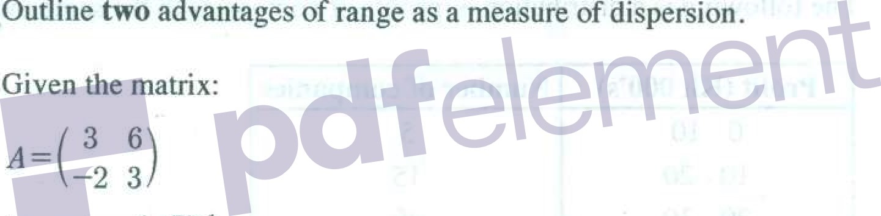(a)(2 marks)

(b)

determine (AT ) I (2 marks)

1. One tenth of items in a production line are defective. In a random sample of 20 items, determine the probability that:

(a) exactly 3 items are defective;

at least I item is defective.

(4 marks)

F

lurn over

SECTION B (60 marks)

Answer any FOUR questions from this section.

1. (a) In a particular cyber cafe, the probability of one of the computers failing to operate is

0.15. If 5 computers are selected at random, determine the probability that:

* + - 1. 2 computers will fail to operate;
      2. less than 3 computers will fail to operate; (iii) 4 computers will operate;

(iv) at least 1 of the computers will fail to operate.

(9 marks)

(b) Explain the meaning of each of the following terms as used in set theory:

(i) universal set; subset; (iii) empty.

(6 marks)

12. (a) The following is a distribution of profits of companies in the same industry:

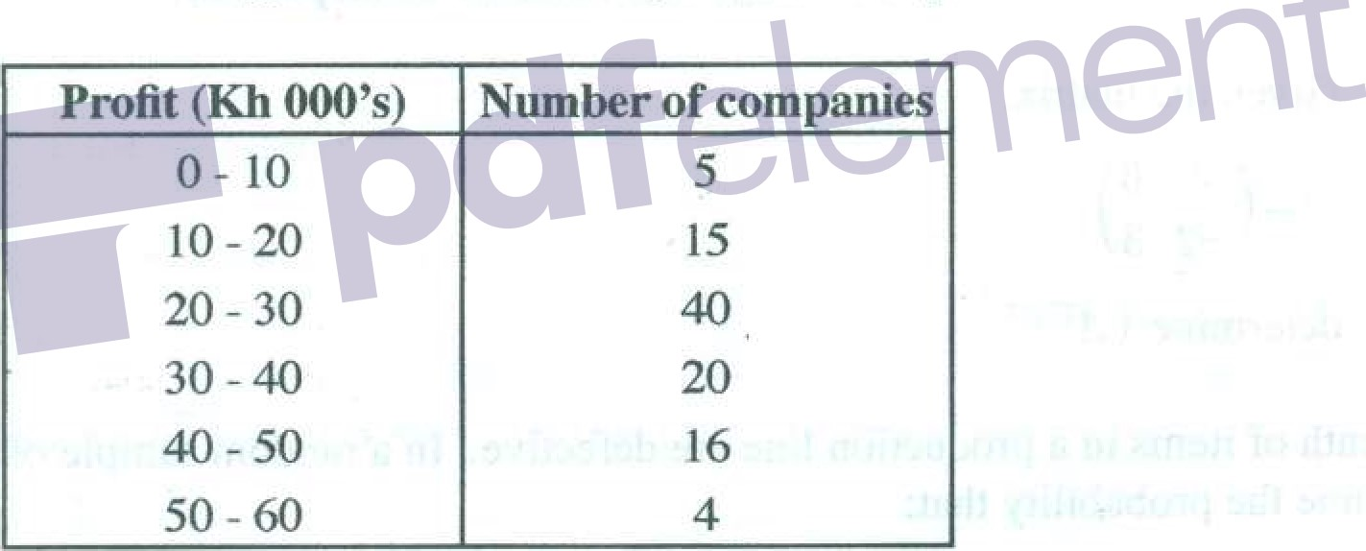

Calculate

the:

* + - 1. mean:
      2. median;
      3. standard deviation;

(iv) Pearson's coefficient of skewness.

(9 marks)



(b) Solve the following simultaneous equations using matrix method:

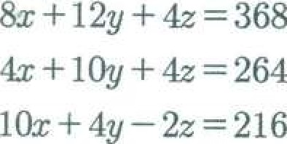

(6 marks)

13. (a) A survey of 210 job applicants was carried out to determine whether they were competent in three foreign languages: French, Spanish and Japanese. The following were the results of the survey:

* + - * 10 were competent in all the three languages;
      * 18 were competent in both Japanese and French;  22 were competent in both Japanese and Spanish;

48 were competent in both Spanish and French;

* + - * 104 were competent in French;  126 were competent in Spanish;  50 were competent in Japanese.

(i) Present the information above in a Venn diagram.

(ii)



Determine

 (1) Spanish but not French;

* + - * + (11) Japanese but not French;
        + (111) neither French not Spanish;  French or Spanish;  both French and Spanish but not Japanese.

(9 marks)

(b) Explain three properties of a normal distribution curve. (6 marks)

flilrn over

newsspot.co.ke

1.4. (a) The daily wages of factory employees is normally distributed with a mean of Ksh 600 and a standard deviation of Ksh 100. Determine the probability that an employee selected at random has a daily wage of:

* + 1. above Ksh 800;
    2. below Ksh 700;
    3. between Ksh 500 and Ksh 650; below Ksh 500.

(9 marks)

(b) (i) Convert +52 to binary using 8 bits machine.

* + 1. Determine the I's compliment of —7.
    2. (I) Add +9 and +4 for 5 bits machine.

 (Il) Determine the equivalent of the results in (I) above.

(6 marks)

15. (a) A shop sold three types of products; A, B and C on a certain day as follows:

2 units of A, 3 units of B and one unit of C for Ksh 490. 3 units ofA, 4 units of B and 2 units of C for Ksh 700.

I unit of A 2 units of B andsl unit of C worksh

 Formulate simultaneoys equation to represent the information above.

(ii) Determinethe:

(l) price per unit of each of the three products;

(Il) total amount to be paid for 4 units ofA and 2 units of B.

(9 marks)

 Explain three challenges that an organization may encounter from the use.of computers in its operations. (6 marks)

THIS IS THE LAST PRINTED PAGE.

